Linear Regression
The linear equation is the central part of linear algebra by which many problems are formulated and solved. It is an equation for a straight line.
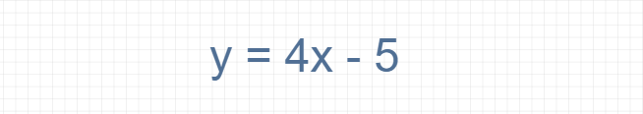
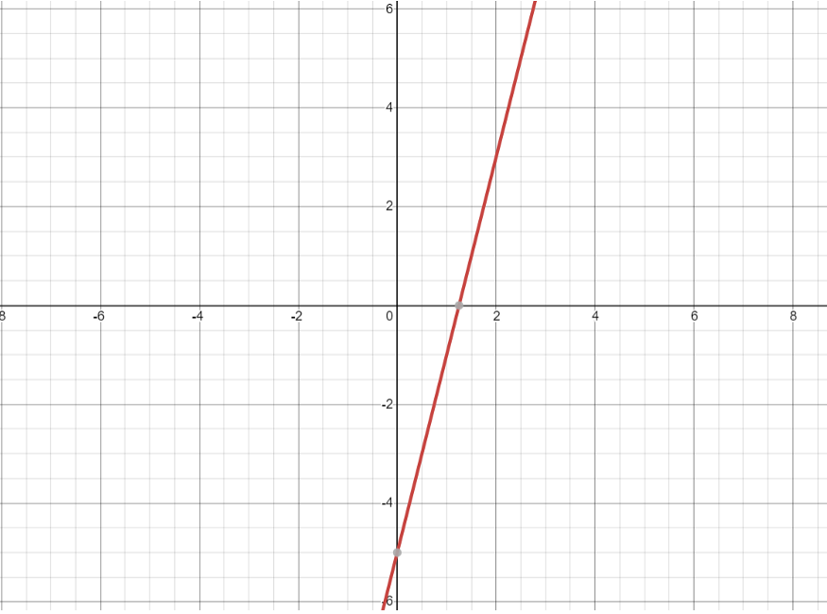
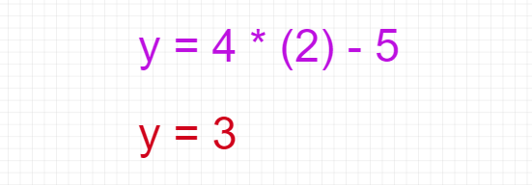
Regression is a process that gives the equation for the straight line. It tries to find a best-fitting line with a specific set of data. The equation of the straight-line bases on the linear equation:
Y = bX + a
Where,
a = It is a Y-intercept and determines the point where the line crosses the Y-axis.
b = It is a slope and determines the direction and degree to which the line is tilted.

The linear equation used in the method “linear_regression”:
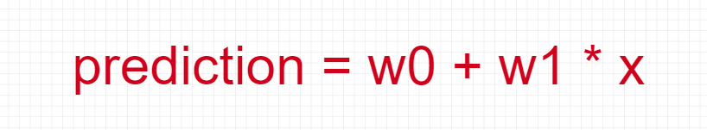

Vector norms measure the magnitude of a vector. Fundamentally, the size of a given variable x can be represented by its norm ||x||, and the norm represents the distance between two variables x and y, and it is represented by ||x-y||.
The general equation of the vector norm:

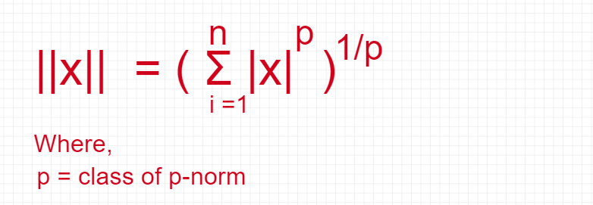

Normalizing refers to the process of making something “standard” or, well, “normal.” In the case of vectors, let’s assume for the moment that a standard vector has a length of 1. To normalize a vector, therefore, is to take a vector of any length and, keeping it pointing in the same direction, change its length to 1, turning it into what is called a unit vector.
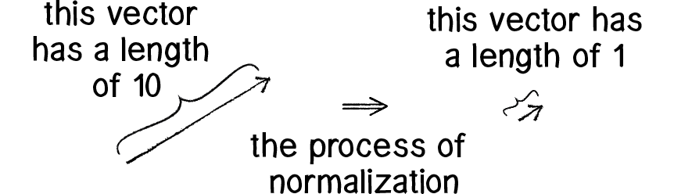
Since it describes a vector’s direction without regard to its length, it’s useful to have the unit vector readily accessible. We’ll see this come in handy once we start to work with forces in the next section.
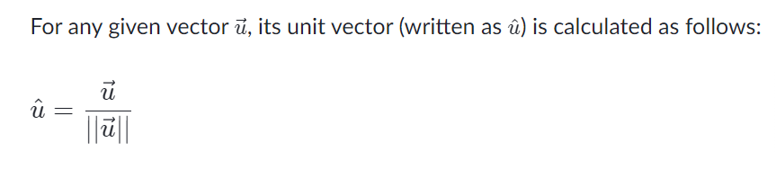In other words, to normalize a vector, simply divide each component by its magnitude. This is pretty intuitive. Say a vector is of length 5. Well, 5 divided by 5 is 1. So, looking at our right triangle, we then need to scale the hypotenuse down by dividing by 5. In that process the sides shrink, divided by 5 as well.
X = 7i + 7j
|X| = sqrt(98)
X = 7/sqrt(98)i + 7/sqrt(98)j
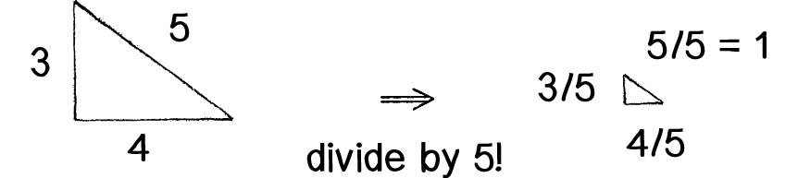

These are the general classes of p-norms:
- L1 norm or Manhattan Norm.
- L2 norm or Euclidean Norm.
L1 and L2 norms are used in Regularization.

L1 norm or Manhattan Norm
The L1 norm on R^n is defined for x ∈ R^n
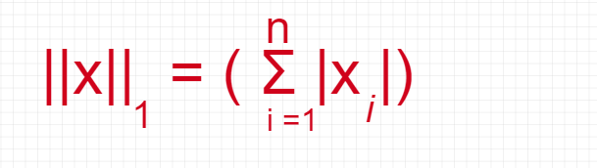
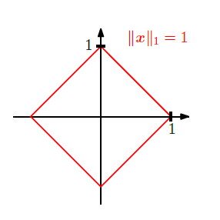

L2 norm or Euclidean Norm
The L2 norm of x∈R^n is defined as:
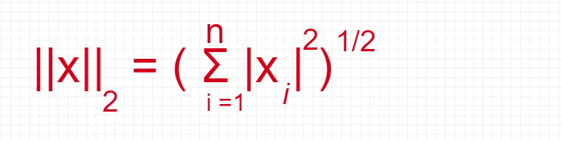
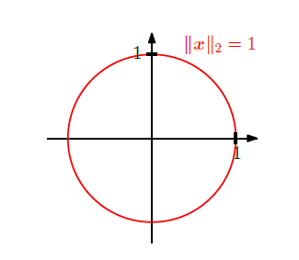

L0 Norm:
It is actually not a norm. Corresponds to the total number of nonzero elements in a vector.
X = 2i + 3j + 0k
For example, the L0 norm of the vectors (0,0) and (0,2) is 1 because there is only one nonzero element.
when having two vectors (username and password). If the L0 norm of the vectors is equal to 0, then the login is successful. Otherwise, if the L0 norm is 1, it means that either the username or password is incorrect, but not both. And lastly, if the L0 norm is 2, it means that both username and password are incorrect.

L1 Norm:
Also known as Manhattan Distance or Taxicab norm. L1 Norm is the sum of the magnitudes of the vectors in a space. It is the most natural way of measure distance between vectors, that is the sum of absolute difference of the components of the vectors. In this norm, all the components of the vector are weighted equally.
Having, for example, the vector X = [3,4]:
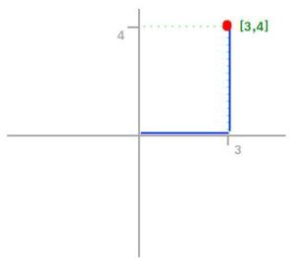
The L1 norm is calculated by
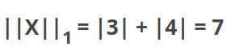
As you can see in the graphic, the L1 norm is the distance you have to travel between the origin (0,0) to the destination (3,4), in a way that resembles how a taxicab drives between city blocks to arrive at its destination.

L2 norm:
Is the most popular norm, also known as the Euclidean norm. It is the shortest distance to go from one point to another.
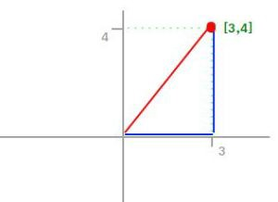
Using the same example, the L2 norm is calculated by
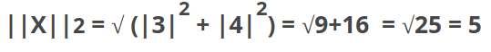
As you can see in the graphic, L2 norm is the most direct route.
There is one consideration to take with L2 norm, and it is that each component of the vector is squared, and that means that the outliers have more weighting, so it can skew results.

L-infinity norm:
Gives the largest magnitude among each element of a vector.
Having the vector X= [-6, 4, 2], the L-infinity norm is 6.
X = 100i + 20j – 700k
700
In L-infinity norm, only the largest element has any effect. So, for example, if your vector represents the cost of constructing a building, by minimizing L-infinity norm we are reducing the cost of the most expensive building.

Regularization in Machine Learning
Regularization is a process of modifying the loss function to penalize specific values of the weight on learning. Regularization helps us avoid overfitting.
It is an excellent addition in machine learning for the operations below:
- To handle collinearity.
- To filter out noise from data.
- To prevent overfitting.
- To get good performance.
These are the standard regularization techniques:
- L1 Regularization (Lasso)
- L2 Regularization (Ridge)
Regularization is the application of the norm.

L1 Regularization (Lasso)
Lasso is a widespread regularization technique.

L2 Regularization (Ridge)
The equation of L2 regularization (Ridge):
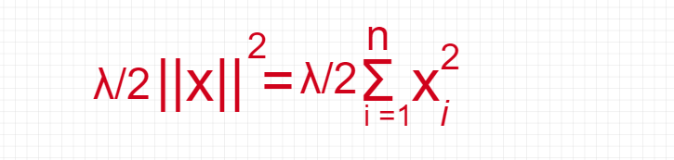
Where, λ = Controls the tradeoff of complexity by adjusting the weight of the penalty term.

Feature Extraction and Feature Selection
The main intention of feature extraction and feature selection is to pick an optimal set of lower dimensionality features to enhance classification efficiency. These terms essentially treat the curse of the dimensionality problem. Feature selection and feature extraction are performed in the matrix.

Feature Extraction
In feature extraction, we find a set of features from the existing features through some function mapping.
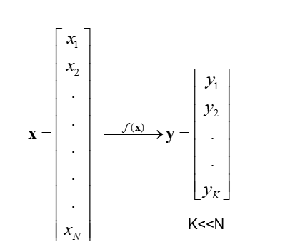

Feature Selection
In feature selection, select a subset of the original features.
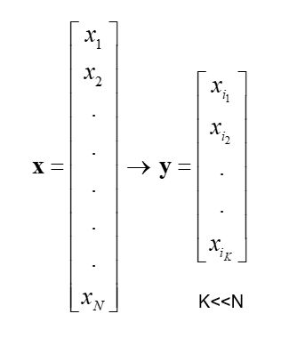
Main feature extraction methods are:
- Principal Component Analysis (PCA)
- Linear Discriminant Analysis (LDA)
PCA is a critical feature extraction method, and it is vital to know the concepts of the covariance matrix, eigenvalues, or eigenvectors to understand the concept of PCA.

Covariance Matrix
The covariance matrix is an integral part of PCA derivation. The below concepts are important to compute a covariance matrix:
- Variance.
- Covariance.

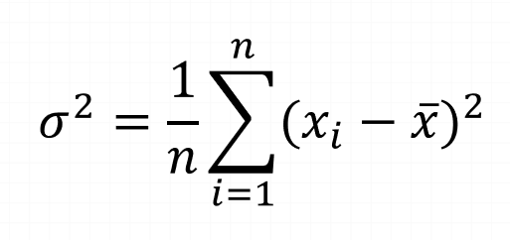
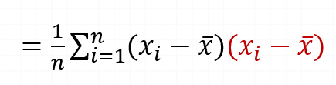
The limitation of variance is that it does not explore the relationship between variables.

Covariance
Covariance is used to measure the joint variability of two random variables.
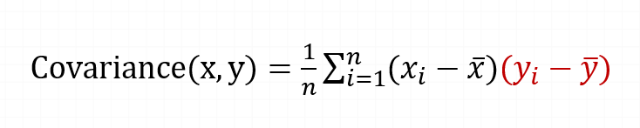

Covariance Matrix
A covariance matrix is a squared matrix that gives the covariance between each pair of given random vector elements.
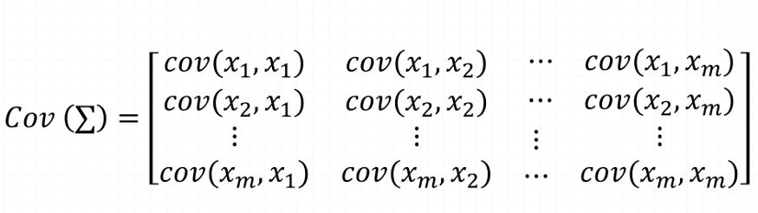
The equation of the covariance matrix:
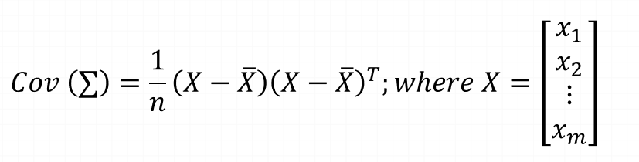

Eigenvalues and Eigenvectors
The definition of Eigenvalues:
Let m be an n*n matrix. A scalar λ is called the eigenvalue of m if there exists a non-zero vector x in R^n such that mx = λx.
and for Eigenvector:
The vector x is called an eigenvector corresponding to λ.

Calculation of Eigenvalues & Eigenvectors
Let m be n*n matrix with eigenvalues λ and corresponding eigenvector x. So, mx = λx. This equation can be written as below:
mx — λx = 0
So, the equation:
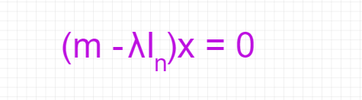
Example:
Calculate eigenvalues and eigenvectors of given matrix m:
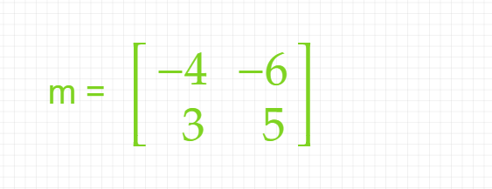
Here, the size of the matrix is 2. So:
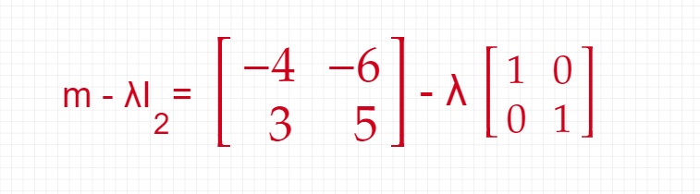
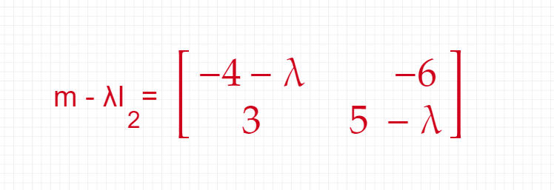
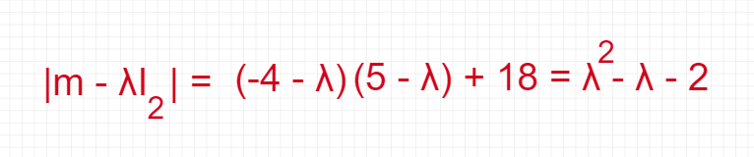
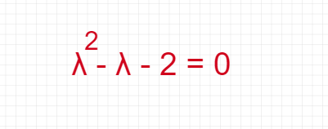
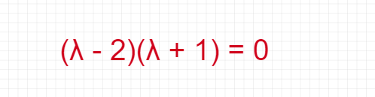
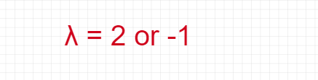
Here, the Eigenvalues of m are 2 and -1.
There are multiple eigenvectors available to each eigenvalue.

Orthogonality
Two vectors v and w are called orthogonal if their dot product is zero [7].
v.w = 0
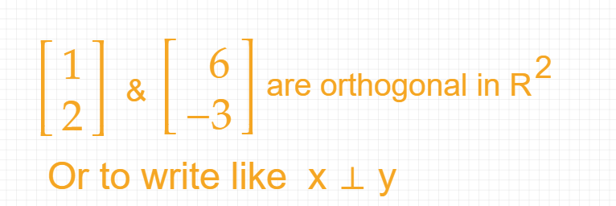

Orthonormal Set
If all vectors in the set are mutually orthogonal and all of the unit lengths, then it is called an Orthonormal set [8]. An orthonormal set that forms a basis is called an orthonormal basis.

Span
Let V is a vector space and its elements are v1, v2, ….., vn ∈ V.

